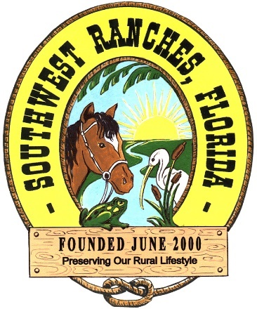
Water Qualit
Town of Southwest Ranches
13400 Griffin Road
Southwest Ranches, FL 33330
Phone: (954) 434-0008
Fax: (954) 434-1490
Website: www.southwestranches.org

Town of Southwest Ranches
PUBLIC NOTICE

The Town of Southwest Ranches shall be meeting for a Special Meeting of the Town Council on Thursday, June 29, 2023, immediately following the Attorney/Client Executive Session scheduled for 7:00 p.m. to discuss the following topic:

- Town of Southwest Ranches v. City of Pembroke Pines
Case: CACE 12-028819 (25)

and any other related matters deemed necessary.

The meeting shall be held in the Southwest Ranches Conference Room, 13400 Griffin Road., Southwest Ranches, FL 33330. Any meeting may be opened and continued and, under such circumstances, additional legal notice would not be provided. Any person may contact the Town Hall at (954) 434-0008 for information.

Russell C. Muñiz, MMC, Assistant Town Administrator/Town Clerk

In accordance with the Americans with Disabilities Act of 1990, persons needing special accommodation (or hearing impaired) to participate in this proceeding or to review any documents relative thereto should contact the Town for assistance at (954) 434-0008 no later than four (4) days prior to the proceedings.

