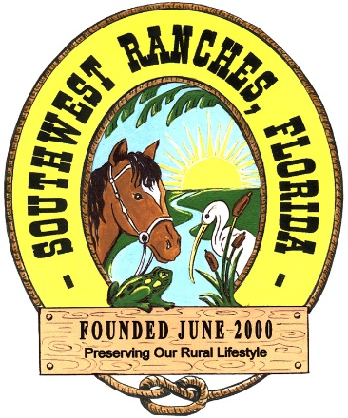
Town of Southwest Ranches
13400 Griffin Road
Southwest Ranches, FL 33330
Phone: (954) 434-0008
Fax: (954) 434-1490
Website: www.southwestranches.org

PUBLIC NOTICE OF ATTORNEY/CLIENT EXECUTIVE SESSION OF THE TOWN COUNCIL OF THE TOWN OF SOUTHWEST RANCHES, FLORIDA

The Town of Southwest Ranches Town Council will meet in an executive session on Thursday, June 29, 2023 beginning at 7:00 p.m. The meeting will be held in the Town of Southwest Ranches Grand Oak Conference Room in Town Hall, located at 13400 Griffin Road, Southwest Ranches, Florida.

Pursuant to Section 286.011(8), Florida Statutes, the Town Council of the Town of Southwest Ranches, Florida, will meet in a Closed Attorney/Client Executive Session to discuss strategy and/or strategy relating to pending litigation in the following case:

- Town of Southwest Ranches v. City of Pembroke Pines
Case: CACE 12-028819 (25)

The executive session will be attended by Mayor Steve Breitkreuz, Vice Mayor Jim Allbritton Council Member Bob Hartmann, Council Member Gary Jablonski, Council Member David Kuczenski, Town Administrator Andrew Berns, Russell Muñiz, Assistant Town Administrator/Town Clerk, and the Town’s attorneys. The session will be recorded by a certified court reporter, and a copy of the transcript will be available at the conclusion of the case.

Russell Muñiz, Assistant Town Administrator/Town Clerk

